SAP CPI and GitHub Synchronization

Agenda:- To build an application to save packages and artifacts in GitHub for backup

Scenarios:-
- Push packages and artifacts from SAP CPI to Github
- Pull packages and artifacts from Github to SAP CPI

Scenario – 1

Externalized Parameters
Parameters | Description
ARTIFACT_TYPE | The type of artifact to push | Possible values:-  IFL - Integration Flow  VM – Value Mapping  MM – Message Mapping  SC – Script Collection  DT – DataType  MT – Message Type  SI – Service Interface
ARTIFACTS_ID | Technical name of the artifact to push
GITHUB_COMMIT_MESSAGE | Github commit message
GITHUB_REPO_NAME | Github repository name to which packages/artifacts to be pushed
GITHUB_OWNER | Github owner name
TENANT_HOST_ADDRESS | SAP CPI tenant API host address
OAUTH_CREDENTIAL | OAuth credentials of SAP CPI tenant | Create OAuth 2.0 client credentials security material
GITHUB_ACCESS_TOKEN | Github Personal Access Token | Create User Credentials security matrial
PACKAGE_ID | Technical name of the package to push to Github

Give Source value for ARTIFACTS_ID and ARTIFACT_TYPE to push a particular artifact to Github repository and leave blank for PACKAGE_ID
Give source value for PACKAGE_ID to push a complete package to Github repository and leave blank for ARTIFACTS_ID and ARTIFACT_TYPE

Execution

Phase - 1
Configure the values for externalized parameters
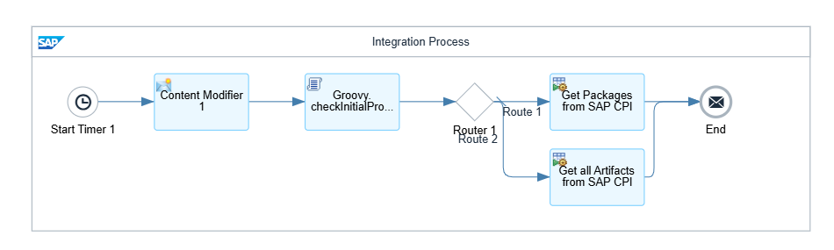
Groovy – 1:- Groovy.checkInitialProperties
Checks if all mandatory externalized parameters are filled according to requirement.

Routes to flow to push artifacts or packages

Phase – 2.1.1
Run a GET request to SAP CPI on configured package technical name
If package exists on CPI tenant we receive metadata, and Package Content
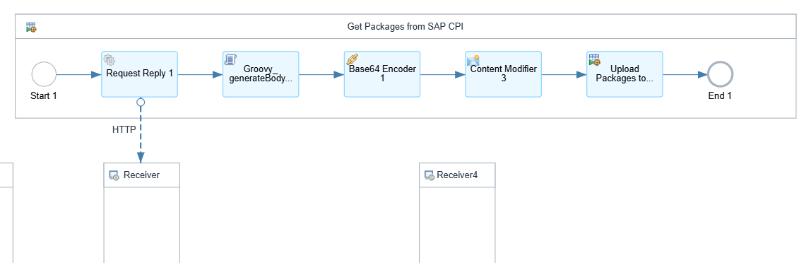
Groovy – 2:- Groovy_generateBodyPackagesGet
Generates a structure in JSON format for received results
Convert the generated structure into binary content using Base64 Encoder
Copy the encoded message in a property OriginalMessage for future use

Phase 2.1.2
Groovy – 3:- Groovy_setHeadersPackagesGet
Set the required headers and HTTP url to run a GET request to https://api.github.com/repos/${property.GITHUB_OWNER}/${property.GITHUB_REPO_NAME}/contents/IntegrationPackages/Zip/${property.PACKAGE_ID}.zip
If package exists we have to update that package, else create a new package.zip in github repository
If package exists, Convert the received JSON format into XML format
Save the SHA received from Github in a property blobSHA
SHA – Secure Hash Algorithm; Github uses SHA as cryptographic signatures to track version control and verify data integrity
Groovy - 4:- Groovy_setBodyHeadersPackagesPut
Generate body format and headers to PUT data into github repository
Run a PUT request on https://api.github.com/repos/${property.GITHUB_OWNER}/${property.GITHUB_REPO_NAME}/contents/IntegrationPackages/Zip/${property.PACKAGE_ID}.zip to create a new resource in Github
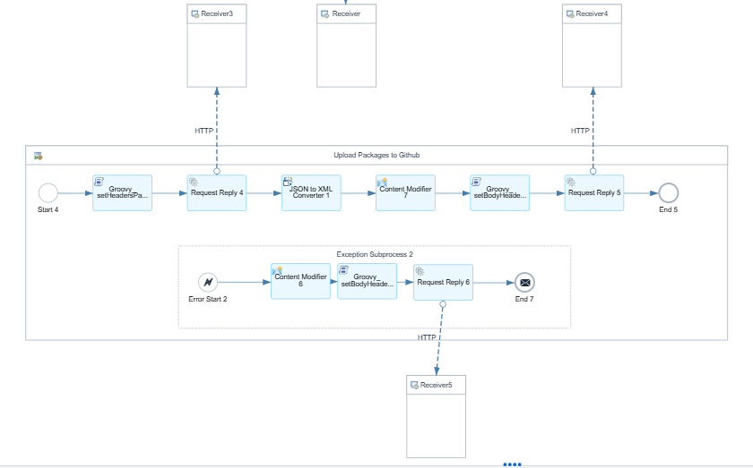

If package doesn’t exist in the Github repository an exception occurs.
In exception subprocess write the update scenario
Fetch the copied OriginalMessage into the body using a content modifier
Groovy – 5:- Groovy_setBodyHeadersPackagesPost
Generate the headers and body to POST to Github repository
Run a PUT request to https://api.github.com/repos/${property.GITHUB_OWNER}/${property.GITHUB_REPO_NAME}/contents/IntegrationPackages/Zip/${property.PACKAGE_ID}.zip

Phase – 2.2.1
Run a GET request to fetch configured artifacts details from CPI tenant
If artifact exists in CPI tenant we get data of that artifact
Convert the receive data into binary content using Base64 encoder
Save this data as OriginalMessage in a property
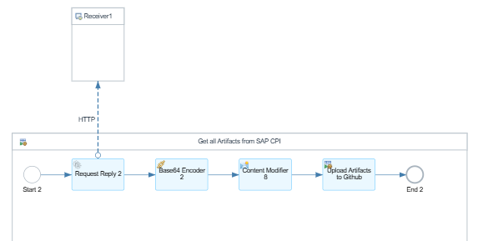

Phase – 2.2.2
Groovy – 6:- Groovy_setHeadersArtifactsGet
Generate headers and HTTP url to GET artifacts into Github
Run a GET request on https://api.github.com/repos/${property.GITHUB_OWNER}/${property.GITHUB_REPO_NAME}/contents/IntegrationArtifacts/Zip/${property.ARTIFACTS_ID}.zip
If artifact exists in the Github we receive that artifact data
Convert the received content fron JSON to XML
Fetch the SHA from the content
Groovy – 7:- Groovy_setBodyHeadersArtifactsPut
Set the body for the artifact to PUT into Github to update the artifact
Run a PUT request on
https://api.github.com/repos/ https://api.github.com/repos/${property.GITHUB_OWNER}/${property.GITHUB_REPO_NAME}//contents/IntegrationArtifacts/Zip/${property.ARTIFACTS_ID}.zip
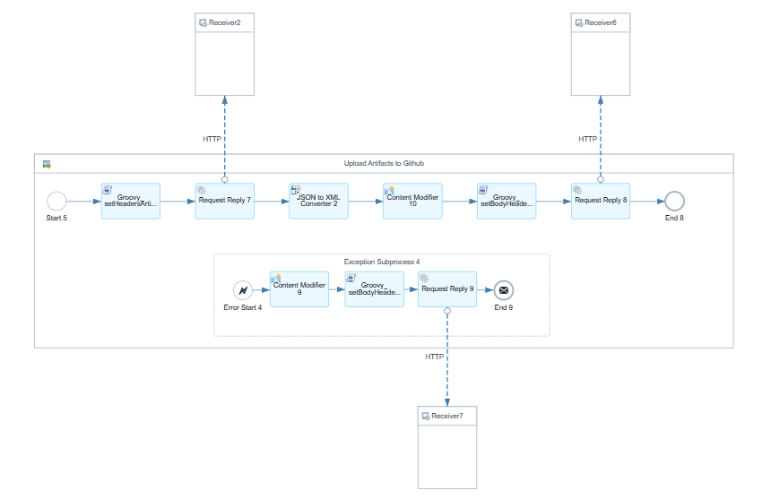

If artifact doesn’t exist in Github repository we get an exception
Write create scenario in exception subprocess
Restore the saved OriginalMessage into body using Content Modifier
Groovy – 8:- Groovy_setBodyHeadersArtifactsPost
Set the body to POST into Github repository
Run a POST request to Github repository
https://api.github.com/repos/${property.GITHUB_OWNER}/${property.GITHUB_REPO_NAME}//contents/IntegrationArtifacts/Zip/${property.ARTIFACTS_ID}.zip

Scenario – 2

Externalize Parameters
Parameters | Description
OAUTH_CREDENTIAL | OAuth credentials of SAP CPI tenant | Create OAuth 2.0 client credentials security material
GITHUB_ACCESS_TOKEN | Github Personal Access Token | Create User Credentials security matrial
TENANT_HOST_ADDRESS | SAP CPI tenant API host address
ARTIFACT_TYPE | The type of artifact to push | Possible values:-  IFL - Integration Flow  VM – Value Mapping  MM – Message Mapping  SC – Script Collection
GITHUB_OWNER | Github owner name
GITHUB_PATH | Path of the Github of artifact/package zip file
GITHUB_REPO_NAME | Github repository name to which packages/artifacts to be pushed
PULL_PACKAGE_ID | Package technical name to push a complete package into SAP CPI tenant
ARTIFACT_ID | Technical name of the artifact to push to CPI tenant
ARTIFACT_PACKAGE_ID | Technical name of the package to which push a particular ARTIFACT_ID

Give source value for PULL_PACKAGE_ID if you want to fetch a complete package and its artifacts to CPI tenant and leave blank for ARTIFACT_ID and ARTIFACT_PACKAGE_ID
Give source value for ARTIFACT_ID and ARTIFACT_PACKAGE_ID to fetch a artifact from Github and push into a particular package and leave blank for PULL_PACKAGE_ID

Phase – 1
Configure values for externalized parameters
Groovy – 1:- Groovy_checkInitialProperties
Checks if all mandatory externalized parameters are filled according to requirement.
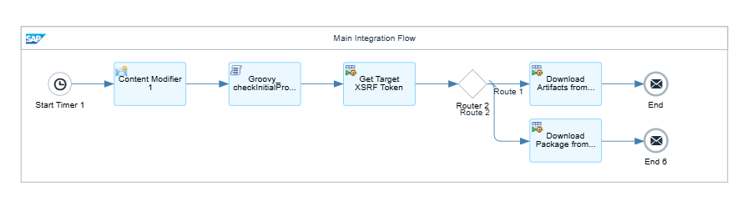

Phase – 2
Set a header X-CSRF-Token and set value “Fetch”
Run a GET request on ${property.TENANT_HOST_ADDRESS}/api/v1
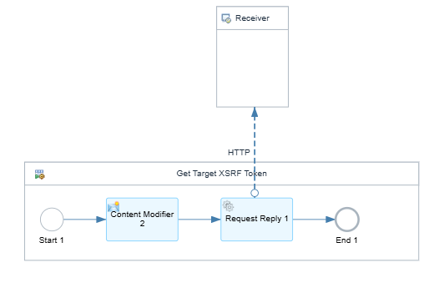

Phase – 3.1.1
Groovy – 2:- Groovy_setHeadersPackagesGet
Set headers to run a GET request to fetch PULL_PACKAGE_ID data from github repository
Run a GET request on https://raw.githubusercontent.com/RushikeshReddy12/SAP_CPI_2/main/IntegrationPackages/Zip/${property.PULL_PACKAGE_ID}.zip
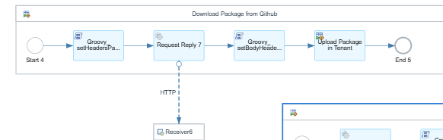
If package exists in the github repository we get the zip file content
Groovy – 3:- Groovy_setBodyHeadersPackages
Set headers and body format of the receiver content

Phase 3.1.2
Run a POST request on ${property.TENANT_HOST_ADDRESS}/api/v1/IntegrationPackages
If a package exists with same technical name we get and exception
It is required to delete the package with same technical name manually as SAP CPI API doesn’t allow to run PUT request to update it’s resources through endpoint
Now we have created a shell package with technical name provided
Groovy – 4:- Groovy_setBodyPackagesArtifactsPost
Identify the Body format for the artifact and dynamically identify the type of artifact to generate the HTTP Url
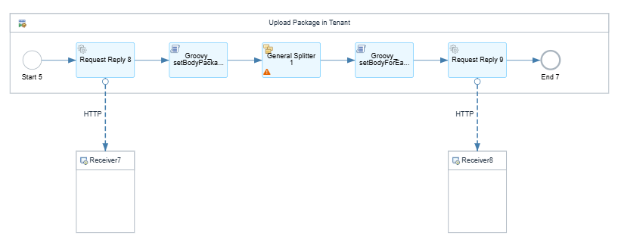
Use a general splitter to separate each artifact formatted in the earlier groovy script
Groovy – 5:- Groovy_setBodyForEachPackageArtifacts
Set headers and body format for each artifact to run POST request on our shell package
Run a POST request on ${property.TENANT_HOST_ADDRESS}${property.artifactEndpoint}

Phase 4.1.1
Groovy – 6:- Groovy_setHeadersArtifactsGet
Set headers to run a GET request to get the artifact details from github
Run a GET request on https://raw.githubusercontent.com/${property.GITHUB_OWNER}/${property.GITHUB_REPO_NAME}/main/IntegrationArtifacts/Zip/${property.ARTIFACT_ID}.zip
If artifact exists we get the details of that artifact
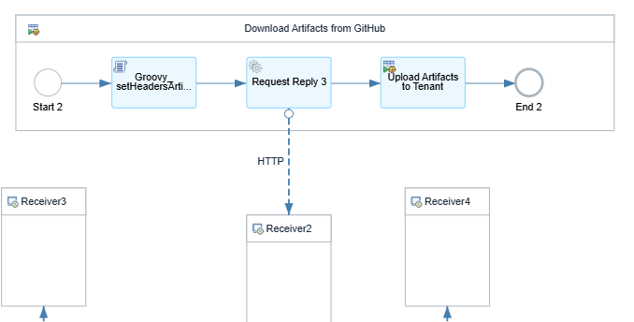

Phase 4.1.2
Convert the received into Base64 encoder
Store this content in a property with name OriginalMessage fro future use
Run a GET request on ${property.TENANT_HOST_ADDRESS}/api/v1/IntegrationDesigntimeArtifacts(Id='${property.ARTIFACT_ID}',Version='active')
If artifact already exists on CPI tenant we get an exception then write update scenario in exception subprocess, else continue with create scenario
Restore the save original message back into the body using a content modifier
Groovy – 7:- Groovy_setBodyArtifactsPost
Groovy – 8:- Groovy_setBodyArtifactsPut
Set the headers to Put/Post to CPI tenant and dynamically change the HTTP url based on the type of artifact
Run a POST request on ${property.TENANT_HOST_ADDRESS}/api/v1/IntegrationDesigntimeArtifacts
Based on artifact type set in previous groovy step
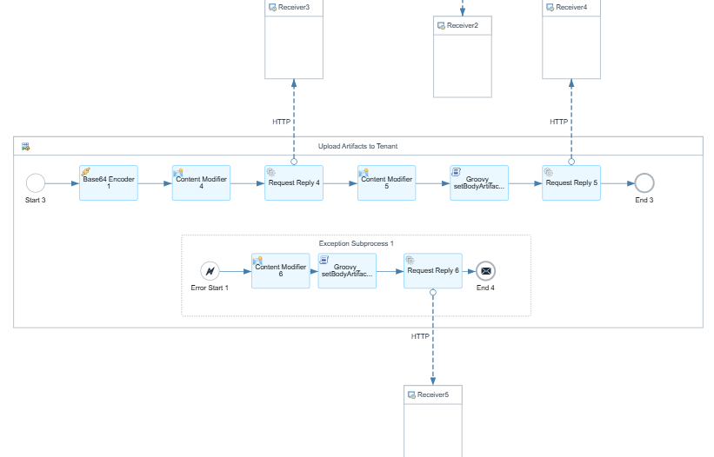

Reference:-
Please find all the groovy scripts on:-
https://github.com/RushikeshReddy12/SAP_CPI_2/tree/main/Groovy%20Scripts

